**CSE320: Data Communications** 

**Quiz-2**

**Total Marks: 15**

**Name: ID: Sec: 25**

**1.** **(a)** Given, a composite periodic signal passing through a channel consists of 7 frequency components of 250, 300, 550, 700, 900, 1150 and 2250 MHz. The signal-to-noise ratio for this channel is 36. Calculate the appropriate bit rate and signal level for the channel. [2.5]

**(b)** 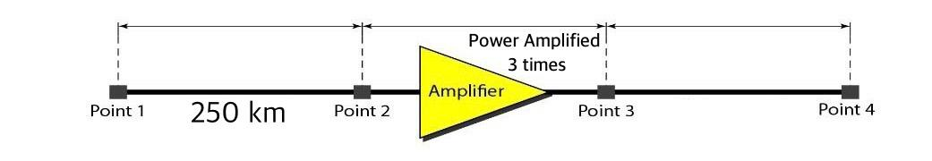

Suppose, the signal power is 550 mW at Point 1. The power loss rate from Point 1 to Point 2 is 1.5 mW/km. The final attenuation from Point 1 to Point 4 is -9.5 dB. Calculate the attenuation for the signal from Point 3 to Point 4. [2.5]

**2.** **(a)** Decode the binary bits using the **Bipolar AMI** line coding scheme. [2.5]

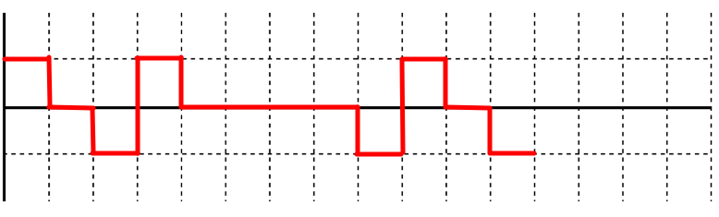

Binary bits:

**(b)** Now apply a technique to replace four consecutive 0s in the encoded data without increasing the number of bits and signals. Write the name of the scheme. [2.5]

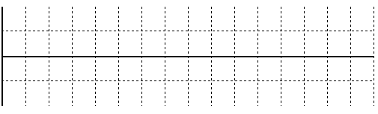

**3.** The following figure depicts a sampled analog signal for digital signal representation. By applying the concept of **Pulse Code Modulation**, assume there will be **3-bit code words** for each sampled amplitude. Show the **Normalized Quantized Value**, **Quantization Code** and **Binary Encoded Value** for the given analog signal value at different time stamps. Assume that the sampling amplitudes are between -25V to +25V. [5]

